Learner Guide

Module 6 – Introduction to Artificial Intelligence, Machine Learning, Deep Learning,
Occupational Certificate: Artificial Intelligence Software Developer

Module # | 251201-002-00-KM-06
NQF Level | 4
Notional hours | 50
Credit(s) | 5
Curriculum Code | 251201002
Qualification Title | Occupational Certificate: Artificial Intelligence Software Developer
Development  Quality Partner | MICT SETA
Occupation or Specialization | AI Software Developer
Associated Occupation | Software Developer

CONTACT INFORMATION:
Name
Contact Address
Telephone (H)
Telephone (W)
Facsimile
Cellular
E-mail

Note to the learner
This Learner Guide provides a comprehensive overview of the module. It is designed to improve the skills and knowledge of learners, and thus enabling them to effectively and efficiently complete specific tasks.
PURPOSE OF THE KNOWLEDGE MODULE
The main focus of the learning in this knowledge module is to build an understanding of artificial Intelligence, its definition and future, as well as the purpose and contribution of AI to society and business

Entry Requirements:
NQF 4

PROVIDER ACCREDITATION REQUIREMENTS FOR THE MODULE:

Physical Requirements:
The provider must have lesson plans and structured learning material or provide learners with access to structured learning material that addresses all the topics in all the knowledge modules as well as the applied knowledge in the practical skills.
QCTO/ MICT SETA requirements
Human Resource Requirements:
Lecturer/learner ratio of 1:20 (Maximum)
Qualification of lecturer (SME):
NQF 6 in industry recognised qualifications with 1 year’s experience in the IT industry
AI vendor certification (where applicable)
Assessors and moderators: accredited by the MICT SETA
Legal Requirements:
Legal (product) licences to use the software for learning and training (where applicable)
OHS compliance certificate
Ethical clearance (where necessary)
Exemptions
No exemptions, but the module can be achieved in full through a normal RPL process

Assessments:

The only way to establish whether you are competent and have accomplished the learning outcomes is through continuous assessments. This assessment process involves interpreting evidence about your ability to perform certain tasks. You will be required to perform certain procedures and tasks during the training programme and will be assessed on them to certify your competence.

This module includes assessments in the form of self-evaluations/activities and exercises. The exercises, activities and self-assessments will be done in pairs, groups or on your own. These exercises/activities or self-assessments (Learner workbook) must be handed to the facilitator. It will be added to your portfolio of evidence, which will be proof signed by your facilitator that you have successfully performed these tasks.

Listen carefully to the instructions of the facilitator and do the given activities in the time given to you.

TOPIC ELEMENTS TO BE COVERED INCLUDE:

KM-06-KT01 : Artificial Intelligence (AI) vs Machine Learning (ML) vs Deep Learning
(DL)
Ethical clearance (where necessary)
Exemptions
No exemptions, but the module can be achieved in full through a normal RPL process

SECTION 1: KM-06-KT01 : Artificial Intelligence (AI) vs Machine Learning (ML) vs Deep Learning (DL)
Learning Outcome
- KT0101 Artificial Intelligence Systems:
- What are AI systems
- Types of AI systems
- Artificial narrow intelligence
- Artificial general intelligence
- Artificial super intelligence
- KT0102 Introduction to Machine Learning (ML):
    - What is ML?
    - How does ML work?
- KT0103 Introduction to Deep Learning (DL):
  - What is DL?
  - How does DL work?

- KT0101 Artificial Intelligence Systems:
- What are AI systems
- Types of AI systems
- Artificial narrow intelligence
- Artificial general intelligence
- Artificial super intelligence
Artificial Intelligence can be divided in various types, there are mainly two types of main categorization which are based on capabilities and based on functionally of AI. Following is flow diagram which explain the types of AI.
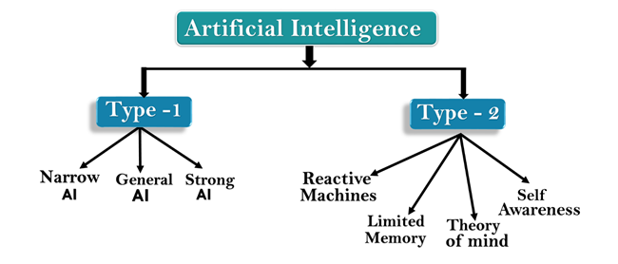
AI type-1: Based on Capabilities
1. Weak AI or Narrow AI:
- Narrow AI is a type of AI which is able to perform a dedicated task with intelligence.The most common and currently available AI is Narrow AI in the world of Artificial Intelligence.
- Narrow AI cannot perform beyond its field or limitations, as it is only trained for one specific task. Hence it is also termed as weak AI. Narrow AI can fail in unpredictable ways if it goes beyond its limits.
- Apple Siriis a good example of Narrow AI, but it operates with a limited pre-defined range of functions.
- IBM's Watson supercomputer also comes under Narrow AI, as it uses an Expert system approach combined with Machine learning and natural language processing.
- Some Examples of Narrow AI are playing chess, purchasing suggestions on e-commerce site, self-driving cars, speech recognition, and image recognition.
2. General AI:
- General AI is a type of intelligence which could perform any intellectual task with efficiency like a human.
- The idea behind the general AI to make such a system which could be smarter and think like a human by its own.
- Currently, there is no such system exist which could come under general AI and can perform any task as perfect as a human.
- The worldwide researchers are now focused on developing machines with General AI.
- As systems with general AI are still under research, and it will take lots of efforts and time to develop such systems.
3. Super AI:
- Super AI is a level of Intelligence of Systems at which machines could surpass human intelligence, and can perform any task better than human with cognitive properties. It is an outcome of general AI.
- Some key characteristics of strong AI include capability include the ability to think, to reason,solve the puzzle, make judgments, plan, learn, and communicate by its own.
- Super AI is still a hypothetical concept of Artificial Intelligence. Development of such systems in real is still world changing task.
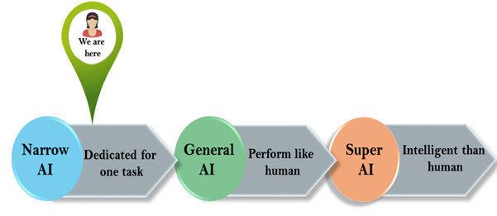
Artificial Intelligence type-2: Based on functionality
1. Reactive Machines
- Purely reactive machines are the most basic types of Artificial Intelligence.
- Such AI systems do not store memories or past experiences for future actions.
- These machines only focus on current scenarios and react on it as per possible best action.
- IBM's Deep Blue system is an example of reactive machines.
- Google's AlphaGo is also an example of reactive machines.
2. Limited Memory
- Limited memory machines can store past experiences or some data for a short period of time.
- These machines can use stored data for a limited time period only.
- Self-driving cars are one of the best examples of Limited Memory systems. These cars can store recent speed of nearby cars, the distance of other cars, speed limit, and other information to navigate the road.
3. Theory of Mind
- Theory of Mind AI should understand the human emotions, people, beliefs, and be able to interact socially like humans.
- This type of AI machines are still not developed, but researchers are making lots of efforts and improvement for developing such AI machines.
4. Self-Awareness
- Self-awareness AI is the future of Artificial Intelligence. These machines will be super intelligent, and will have their own consciousness, sentiments, and self-awareness.
- These machines will be smarter than human mind.
- Self-Awareness AI does not exist in reality still and it is a hypothetical concept.

- KT0102 Introduction to Machine Learning (ML):
    - What is ML?
    - How does ML work?
What is ML in simple?
“In classic terms, machine learning is a type of artificial intelligence that enables self-learning from data and then applies that learning without the need for human intervention. In actuality, there are many different types of machine learning, as well as many strategies of how to best employ them.”

Machine learning is a form of artificial intelligence (AI) that teaches computers to think in a similar way to how humans do: Learning and improving upon past experiences. It works by exploring data and identifying patterns, and involves minimal human intervention.

How does a ML model work?

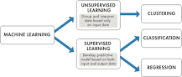

Supervised machine learning builds a model that makes predictions based on evidence in the presence of uncertainty. A supervised learning algorithm takes a known set of input data and known responses to the data (output) and trains a model to generate reasonable predictions for the response to new data.

- KT0103 Introduction to Deep Learning (DL):
  - What is DL?
  - How does DL work?

Deep Learning is a superlative machine learning method as it allows predictive analytics outputs form given a set of inputs with almost zero defect. DL can use supervised and unsupervised learning to train the model. The term “deep” usually refers to the number of hidden layers in the neural network.

What is Introduction to deep learning?

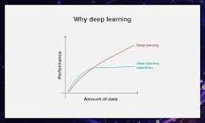

Deep Learning is a subset of Machine Learning that uses mathematical functions to map the input to the output. These functions can extract non-redundant information or patterns from the data, which enables them to form a relationship between the input and the output.

What is DL in machine learning?
Deep learning
Deep learning is a machine learning technique that is inspired by the way a human brain filters information, it is basically learning from examples. It helps a computer model to filter the input data through layers to predict and classify information.

Internal Assessment Criteria and Weight

- IAC0101 Concepts and terminology related to AI, ML and DL are understood and described
- IAC0102Link between AI, ML and DL is understood and described

Good Luck!!

